# DECLARATION

I, Suleiman Faiz Muhammad, hereby declare that this dissertation titled "ONLINE HOSPITAL BILLING SYSTEM," is entirely my own work, unless otherwise acknowledged, and that it has not been submitted as a project for any degree or examination in this or any other university.

I further state that this work is neither private nor confidential. I permit Baze University to keep a copy of it and use it as a resource for its academic and research endeavours.

Date: [28/08/2023]

Signature: [Supervisor's Signature] Date: [Date]

Signature: [Second Supervisor's Signature] Date: [Date]

# 

# DEDICATION

I dedicate my report to my devoted parents, whose support and prayers have helped me get to this point, as well as to all the dedicated and well-respected lecturers. Additionally, I want to dedicate this report to all my lecturers and friends who helped me tremendously with this assignment.

I also want to dedicate this to everyone for their compassion, support, and encouragement. May Allah bless them all.

# 

# ACKNOWLEDGEMENTS

God, the creator of mankind, the most merciful and kind, deserves all praise and appreciation for his blessings, protections, courage, and guidance. Dr Usman Abubakar, who stood by me and made sure I completed this project efficiently and effectively, has my undying thanks. I also want to express my gratitude to my parents for their continuing support, direction, and encouragement in ensuring that I complete this program successfully. I would also like to thank my instructors and everyone else who has helped me get to this point in my academic career.

# ABSTRACT

This study addresses the pressing issues in Nigeria's healthcare system, characterized by the unavailability of free healthcare services in hospitals and inefficient service delivery. Many healthcare facilities in the country lack adequate information technology resources, resulting in subpar primary healthcare and a rise in chronic diseases. The research aims to evaluate the potential advantages of implementing an online billing system in federal hospitals across Nigeria.

The online billing system is recognized as a vital tool to fortify the healthcare system and foster economic growth. It comprehensively addresses crucial aspects of hospital management, encompassing patient care, safety, cost reduction, and operational efficiency. By granting easy access to critical information, this system facilitates informed decision-making and eradicates the limitations associated with manual billing procedures.

This study focuses on the management of financial data and communication between hospitals and patients. It seeks to investigate the effectiveness of an Electronic Medical Billing System (EMBS) and its role in enhancing healthcare delivery. The primary target of this research is federal hospitals, with the goal of determining how a web-based hospital billing system can enhance the overall healthcare experience for both patients and healthcare providers.

The implementation of an online billing system in Nigerian Navy hospitals holds the potential to streamline operations, elevate patient care standards, and reduce healthcare costs. This research endeavors to shed light on the manifold benefits of such a system and contribute to the progression of healthcare practices within the country.

Keywords: Nigeria, healthcare, online billing system, hospitals, information technology, patient care, cost reduction, efficiency, Electronic Medical Billing System (EMBS), healthcare delivery, financial data management, communication, economic growth, healthcare practices, Nigerian Navy.

# List of Tables and Figures

Table 1 35

Table 2 35

Table 3 38

Table 4 40

Figure 1 19

Figure 2 46

Figure 3 47

Figure 4 53

Figure 5 53

Figure 6 54

Figure 7 55

Figure 8 57

Table of Contents

DECLARATION 1

DEDICATION 2

ACKNOWLEDGEMENTS 3

ABSTRACT 4

List of Tables and Figures 5

CHAPTER ONE 8

1.1 BACKGROUND OF THE STUDY 8

1.2 Statement of the Problem 10

1.3 Aim and Objectives 11

1.4 OBJECTIVES OF THE STUDY 11

1.5 Significance of the Study 11

1.6 SCOPE OF THE STUDY 12

CHAPTER 2 13

2.1 Introduction 13

2.2 Nature of Hospital Billing System 15

2.3 Features of Hospital Information Systems 16

2.4 Hospital Management System Modules 19

2.5 Roles OF Information Technology In Hospital Billing System 22

2.6 Relationship Between Information Technology and Patient System In The Health Care 25

2.7 Nature and Types of Billing systems 26

CHAPTER THREE 30

3.1 Overview 30

3.2 Proposed Model 31

3.3 Methodology 32

3.4 Tools and Techniques 34

3.5 Ethical Consideration 35

3.6 Requirement Analysis 37

3.7 Requirements Specifications 39

3.8 System Design 44

CHAPTER FOUR 60

4.1 Overview 60

4.2 Main Features 60

4.3 Implementation Problems 60

4.4 Overcoming Implementation Problems 61

4.5 Testing 62

4.6 User Guide 63

4.7 Result Presentation 65

References 68

# 

# CHAPTER ONE

ONLINE HOSPITAL BILLING SYSTEM

INTRODUCTION

## BACKGROUND OF THE STUDY

From time immemorial, human race occasionally faced drastic effects of diseases which necessitated the development of health care facilities where patients are cured of common illnesses and diseases emanating from pandemics (Sikiru and Oyekunle 2021). Since then, hospitals and healthcare centres remain the custodians for care and treatment of sick persons or persons that need to be isolated to reduce the spread of pandemics (Sikiru and Oyekunle 2021). Hospitals are healthcare institutions providing patient treatment by specialized staff who usually bill the beneficiaries. Similarly, hospital billing system is a process of showing an invoice on how much one owes or must pay for service rendered (Ajayi et aal 2019). The billing could be in the form of manual system, in-house electronic/computerized system or online system which is mostly determined by the levels of funding, ICT equipment and quality of human resource available to a hospital. Historically, hospitals are funded by religious organizations, charity, or community leaders wherein the services rendered, or drugs administered are mostly free of cost.

In Nigeria, the most patronized hospitals are government or charity funded which are no longer free of cost and are manually operated with little computerization that is insufficient to guarantee efficient service delivery and deter fraudulent practices. It was gathered that there are 33,303 general hospitals, 20,278 primary health centers and posts, and 59 teaching hospitals or federal medical centers (Akinode, 2017) that are mostly operated using minimal information technology assets. These hospitals provide the avenue for primary healthcare delievery where preventive care is administered that may foreclose expensive hospital treatment of a patient. The primary care requires constant interface and personal connection with patients as well as community outreach programs which is made easier and effective with online billing so as to promote good health practices and preventive strategies for teeming population. In this way, a cost-effective healthcare delivery could be achieved by nations or communities and this effort has the tendency to reduce global burden of disease by as much as 70% (Christiansen, 2021). It is for these reasons that almost all wealthy nations provide balance proportion of health workers and facilities in relation to national population and apply information technology such as the online billing system in their healthcare practices (Akinode, 2017). However, in Nigeria there appears ineffective governmental effort to entrench the tenets required for primary healthcare to thrive. As a result, demands for both primary and long-term healthcare of chronic diseases is on the rise (Geek for Geeks, 2021). Consequently, the state of most public owned hospitals in Nigeria has become pathetic and a mere centre for managing illnesses leading to death instead of centres of excellence in patient cure as argued (Kabir, Saidin, & Ahmi, 2017).

It is therefore against this backdrop that this research seeks to assess the utility of online billing system in the health sector of Nigeria. The study will limit its analysis to the online billing system in federal hospitals with focus on financial data management and how communication is administered between the hospital and patients. Therefore, the purpose of this study is to examine the potential benefits of the Electronic Medical Billing System (EMBS) and its ultimate contribution to improving healthcare delivery in federal hospitals in Nigeria.

Appropriate online billing systems are seen as crucial to strengthen the health system in developing countries and in pursuing the economic growth of the nation. An online hospital billing system addresses the entire major functional areas of modern hospital management operations. The package enables improved patient care, patient safety, reduced costs, and efficiency (Brook, 2020). It provides easy access to critical information thereby enabling management to make better decisions on time. This study proposes a web-based hospital billing system that can help eliminate the limitations observed in the manual system.

## Statement of the Problem

In the Nigerian Navy's medical facilities, similar to many public hospitals, the prevailing practice is manual record keeping for health-related data. However, this method faces significant challenges such as limited physical storage space when dealing with a substantial influx of patients. Moreover, the handwritten entries by personnel responsible for record-keeping are often unclear, and there is the added concern of potential damage from biological agents like termites.(Funmilola et al 2015).

Proper record management is of very important to every organization or company. Most organizations have poor record management which leads them to having many problems during auditing.

Hospital is an institution that is built, staffed, and equipped for the diagnosis of disease; for the treatment, both medical and surgical, of the sick and the injured; and for their housing during this process, it is an organization that deals with everyday transaction. The record of bills is what is used to determine success or failure and is what will be used for further decision as to continue with the present pattern of business or change to a new style. The manual record keeping and billing is very slow and is error prone. No proper security is usually provided to the record and so can be tempered with by any individual either intentional or accidental. Another problem with the manual system of record keeping and billing is the natural disaster. Disasters like fire outbreak etc can cause damages or even total vanish of all records.

## Aim and Objectives

The aim of this work is to design and implement a Hospital Billing System for the Nigerian Navy Hospitals across the country.

## 1.4 OBJECTIVES OF THE STUDY

1. To assess the major features of the various hospital billing system.

2. To examine the problems associated with the various hospital billing system in Nigeria.

3. To provide secured and efficient way for patients to pay their medical bills.

4. To offer strategies for effective and acceptable billing system in the federal hospitals.

## 1.5 Significance of the Study

The research is set out to understand the nature, problems and issues associated with hospital billing system in the Nigerian Navy. The study explored the problems of billing systems in federal hospitals in Nigeria and their implications on the healthcare service delivery. It is hoped that the outcome of this study will be beneficial to the Government and hospital institutions in Nigeria. It is also expected that the study will be beneficial to both the management and staff within hospital establishment.

## 1.6 SCOPE OF THE STUDY

Implementing a Computerized Hospital Billing System for the Nigerian Navy

1. Focus Area: Hospital Billing System Implementation The study will primarily focus on the design and implementation of a computerized hospital billing system specifically tailored to the healthcare facilities within the Nigerian Navy. The system will cover aspects related to patient registration, medical service documentation, invoicing, payment processing, and reporting.
2. Exclusion of Clinical Operations: The study will not delve into the clinical aspects of healthcare provided by the Nigerian Navy. It will not cover medical diagnoses, treatment procedures, or patient care protocols. The primary emphasis will be on the billing and administrative processes associated with healthcare services.
3. Navy-Specific Considerations: The study will consider the unique operational environment of the Nigerian Navy, including factors such as maritime operations, remote locations, and potential challenges related to access to medical facilities. The system design will need to accommodate these Navy-specific factors.
4. Limited to Nigerian Navy Healthcare Facilities: The scope will be confined to healthcare facilities managed by the Nigerian Navy. Private medical institutions or public hospitals outside of the Navy's domain will not be part of the study.
5. No Exploration of Hardware/Software Development: While the study will focus on the design and modalities of implementation, it will not include the development of hardware components or software programming. The study will assume the availability of necessary technical expertise for system development.
6. Billing and Financial Aspects Only: The study's core will revolve around the billing processes, revenue management, and financial aspects of the hospital operations. Other administrative tasks related to patient records management or medical inventory control will not be extensively covered.
7. Deployment and Testing within the Navy: The proposed system's deployment and testing will be within the controlled environment of the Nigerian Navy's healthcare facilities. The study will not cover potential challenges that might arise if the system is adopted by civilian medical institutions.
8. Limitation to Current Technological Landscape: The study will work within the technological landscape existing up to the date of the study's completion. Any future advancements in technology beyond this point will not be considered.

# CHAPTER 2

LITERATURE REVIEW

## 2.1 Introduction

Nowadays hospital services are redefined by the digital revolution which has become a driver of change and paved the way for intersection between technology and healthcare (Anusi and Mutambara 2022). In the past, hospital management is dominated by principle of ‘more is better’ than ‘less is better’ in terms of human resources holding costs which invariably constituted more than half of total revenues (Akande and Yahaya 2014). Obviously, the driving force under the ‘more is better’ principle was quality and access while cost containment, quality and access forms the bedrock of the ‘less is better’(Ibid).

Digital technology revolution in hospital services therefore enhances performance and increased efficiency by making effective communication between healthcare providers and patients easier especially in advance countries (Anusi and Mutambara 2022). However, despite the emergence of digitalization in hospital management and its significance, most third world countries especially Nigerian hospitals found it difficult to contain cost by reducing labour and increase digitalization towards better productivity. This was attributed to insufficient knowledge of information technology, reluctance to imbibe the tenets of digital technology and lack of political will to entrench accountability in the management of public hospitals (Akande and Yahaya 2014).

The conventional trend of digital technology applicable in hospitals to contain cost and increase productivity is the online hospital billing system which albeit is being relegated in Nigeria by most publicly owned hospitals. Therefore, as this neglect continues, there must be corresponding endeavours to highlight the utility of digital technology in the management of the hospitals and patient care. Consequently, scholars have written about the problems associated with hospital billing systems and its implication on the efficiency of hospitals, well-being of the populace and economy of nations. In this Chapter, the researcher examined the views of scholars and other related issues on Hospital Management Systems and online hospital billing system.

## 2.2 Nature of Hospital Billing System

The modern Hospital Management System (HMS) is based on high technology and information-intensive processes that are governed by democratic mechanisms in which stakeholders influence decision processes (Zwass 2020). Techopedia, (2011) reported that a survey of 2752 European hospital managers indicates substantial influence of technology on hospital services. It was opined that healthcare funding depends significantly on sophisticated patient and diagnosis classifications, adding that application of IT in diagnostic and treatment processes will improve networks of clinical, hospital, and healthcare management processes.

Healthcare management could be direct and non-direct care. Buchbinder and Thompson (2010) asserted that direct care organizations provide care directly to a patient in need of hospital services. Non-direct care settings only support the care of individuals through products and services made available to direct care organizations. Thus, non-direct health care organizations provide services such as online billing system for improve medical care, management decision-making, and the hospital's operational efficiency (Ibid). This study agreed with this classification of health care management because hospitals need to outsource services that are outside administering patients which is their core competence. They could outsource billing services to specific department or service provider that could adopt computerize billing, adopt online rendition of the bills in order to reduce internal interferences and other lapses. In this way fraud and improper billing would be mitigated and health care delays would be reduced. It is expected that this could make the Hospital Information System (HIS) near accurate for more revenue generation and better HMS.

Farzandipour and Meidani, (2010) asserted that HMS is a tool that facilitates electronic medical records and clinical pathways which could improve patient satisfaction, healthcare quality and reduce healthcare costs. The study agreed with Farzandipour and Meidani (2010) that through HMS, patient satisfaction could be achieved by seamlessly relaying the cost of health care provision highlighting the cost elements to aid transparency and increase patients’ confidence on the hospital. This portrays that implementation of HMS is usually done with the cooperation of the user community consisting of physicians, nurses, administrators, managers, and researchers who could seamlessly be connected through Hospital Information System (HIS). Consequently, neglect of any stakeholder implies missing expertise, skills, knowledge, requirements, and expectations which could breed conflict of interest in the hospital. Therefore, implementation of HIS in the form of online billing system could include analysis of the feelings and perceptions of the aforesaid stakeholders (Ndira, Rosenberger, and Wetter, 2008).

## 2.3 Features of Hospital Information Systems

The growth in ICT and use of Internet has impacted in health care service delivery necessitating the adoption of various HIS (Balaraman and Kosalram 2013). HIS is the integration of information systems aimed at improving patient care by increasing user ‘s knowledge for enhance rational decisions (Vegod 2013). This study considers partial instead of total integration of information systems appropriate to hospital management given that hospitals have various functional departments that could require decoupling of information systems to cater for finance, Human Resource, and technical services amongst others. To corroborate this position, Garrido Et al (2004) have earlier postulated that HIS is the integration of softwares, (not information) in order to capture data in finance, administrative and clinical departments for better management of resources.

Accordingly, to optimize the management of HIS, Haux Et al (1996) opined that HIS goes beyond computer systems, networks and the computer-based application systems that are installed on them, to being a system that comprise the management of the entire information in a hospital. In support of the aforesaid, Balaraman and Kosalram (2013) postulated that HIS are highly demanded to address population needs and helps the physicians and hospital support staff covering various sections with timely and precise service. Consequently, this study agrees with the aforesaid postulations especially given the availability of software market which supports customized solutions to various hospital needs by availing the right information at the right time and in the right form to the right stakeholders (Ibid) thereby facilitating seamless hospital online billing system.

In order to ease the management of HIS including the administration of online billing system, PayamHomayounfar (2012) outlined some tasks which include: storage and monitoring of patient ‘s condition, management and data flow as well as financial aspects. Under the management and data flow, he buttressed the significance of patient data transfers between departments/institutions and data retrieval systems in order to create internal orders electronically to facilitate online billing of patients (Ibid). On the financial aspects, PayamHomayounfar (2012) asserted that HIS fosters efficient administration of finances, highlights the use and monitoring of medicines, makes ordering process more effective while also making the expected and actual treatment cost visible to stakeholders. Consequently, this index constitutes the essential information required to implement online billing system in a hospital. Hence, this study concurred with the assertions of PayamHomayounfar (2012) and adds that there is need for patient literacy on modalities of accessing IT facilities as a precondition for implementing online billing system especially in Nigeria.

PayamHomayounfar (2012) advocated the performance of some tasks as precondition to implementing HIS. Also, Garrido Et al., (2004) postulated some critical success factors without which HIS cannot be implemented. He asserted that mobilization of labor force to accept HIS in order to lower costs, achieve timely rendition of inpatient information system, the commitment of top management to implement targets, stakeholders agreeing to changes in processes, job roles, and organizational culture including keeping management informed and accountable for actions taken as crucial success factors of HIS. Overall, the need for physicians and system analysts to codify the entire hospital discharges and procedures is paramount to implementing HIS (Ibid). Given that the conditions outlined included obtaining the understanding of the labor force and commitment of top management makes Garrido Et al (2004) assertion apt for this study. This is because no policy could be implemented especially in public organizations without the understanding and cooperation of the labor force.

Bearing in mind the crucial success factors and tasks influencing the implementation of HIS, Alice Kok (2009) reported that bill payments at Bumrungrad International Hospital, Thailand was digitised enabling the hospital to double the number of patients daily, increase safety of operations and reduce patients’ bills resulting from reduced human input. In the Hospital, doctors obtained patient records online after which payments for services such as X-ray or blood test results are made online; thus espousing the utility of online billing system. In his contribution to ensuring the success of HIS, Shaw (2002) also espoused the different types of measuring hospital performance to include regulatory inspection, surveys of consumers’ experiences of various hospital services, third-party assessments, statistical indicators and internal assessments. This study agreed with this assertion in that data on actual efficiency of public hospitals could be source through the measurement indices espoused by Shaw (2002). The indices are critical in the utilization of modules for E-hospital management solutions.

## 2.4 Hospital Management System Modules

Hospital Information management modules are tools use to examine the performance and successes of organizations that adopted an information system. Shaw (2003) in recommending the principle of hospital measurement, espoused the Three-layer Graph based meta model (3LGM2), Protected Health Information (PHI) privacy guidelines for Medical Records and Health Level Seven (HL7)/RIM Development Framework. The 3LGM2 uses the Unified Modeling Language based on the combination of functional meta model with technical meta models (Winter, Et al 2003). The functional and technical meta models are required to play a crucial role in the design and development of hospital management systems. Some of the functions include.

1. Requirement Analysis and System Design: Meta models help in analyzing the requirements of a hospital management system and translating them into a coherent design. They provide a structured representation of the system's functions, processes, and relationships, which aids in identifying and documenting the various components and their interactions (Smith et al., 2018).
2. Communication and Collaboration: Meta models serve as a common language and visual representation that facilitate communication and collaboration among stakeholders, including hospital administrators, healthcare providers, and system developers. By using a standardized meta model, stakeholders can discuss and align their understanding of the system's functions and features (Jones & Brown, 2016).
3. System Integration: Hospital management systems often need to integrate with other healthcare systems, such as laboratory information systems, electronic health record systems, and billing systems. Meta models provide a structured framework for identifying the integration points, data flows, and interfaces between different systems, enabling seamless interoperability (Johnson & White, 2019).

The PHI is meant to protect health records of individual that are transmitted by any means Bradley Malin (2010). Figure 1 is the process of de-identification outlined by Malin (2010) which shows identifiers being removed from the health information of individuals, thereby mitigating privacy risks and leveraging secondary use of data on patients for policy assessment and research, amongst other endevours.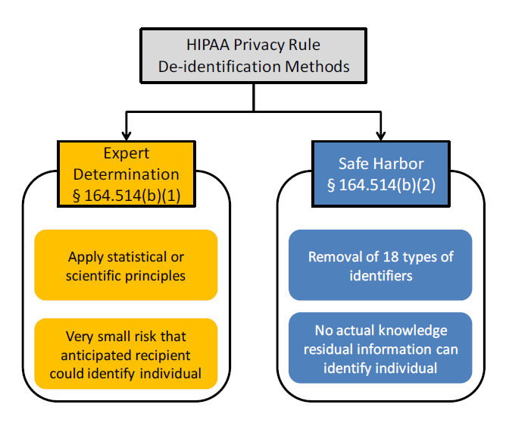

Figure 1

Source: Malin (2010).

In the same connotation, Mauro Regio (2005) asserted that the aim of HL7 is to ensure interoperability in the healthcare, mostly by application of Reference Information Model (RIM), to obtain and refine message specifications in order meet organizational requirements. Schweitzer (2010) utilizes the domain layer, logical tool layer and physical tool layers to analyze a hospital based on different views. For instance, the domain layer layer describes a hospital independent of its implementation by its enterprise functions. The logical tool layer shows the application components that supports hospital functions and are responsible for processing, storage, and transportation of data. The aforesaid assertions are in line with the modalities for facilitating online billing system in hospital management. They are structures that would ensure interface between the various departments in a hospital and other stakeholders outside the hospital organic system. Hence, this study leaned on the Regio interoperability and Schweitzer (2010) logical tool layer to agree that privacy and transportation of data is the bedrock of online billing system. They are the main elements that would display evidence of actions on the utility of the hospital services a patient is paying for.

## 2.5 Roles OF Information Technology In Hospital Billing System

Traditional approaches to hospital billing encompass paper-based information processing and manual data acquisition as well as presentation. The introduction of computer system has massively improved the information management of hospitals being organizations that places high premium on knowledge in their operations. The computers aided the processing of integrated systems that support the comprehensive information requirements of hospitals, including patient, clinical, ancillary, and financial management (Funk, 2010). Hewlett, (2013) asserted that the arrival of IT, made Hospital system to take a new shape and style with a blend of convenience and satisfaction. He added that computers assisted hospitals to interact with patients in a dialogue and through simulations. Through simulations, learning from a patient's room, house, or anywhere in the World has made Hospital system more responsive (Ibid), thereby achieving precision diagnosis of patients. Similarly, computers enabled patients to obtain his/her clearance letter without carrying files around and getting discharge approvals or billing approvals promptly which saves time and money for patients (Scott & Rundall, 2014). This study agrees with the aforesaid assertions and add that computer systems has become the main enabler of administering ailments and other hospital operations which facilitates precision guided diagnosis. However, there seems to be unsatisfactory level of computer knowledge by hospital staff especially in government owned hospitals in Nigeria. Hence, the study suggest the need to improve the level of IT education in the health care sector of Nigeria in order to optimize hospital operations.

The key to optimizing hospital operations is the use of Electronic Health Records (EHR) which facilitate participatory selection process, allows flexible staff roles and responsibilities as well as decisive leadership at important stages. Klein's (2006) asserted that there exists an opportunity to adopt EHR leveraging information technology to improve the efficiency, accuracy, and effectiveness of the health care system. He added that EHR enable the database of a hospital to be accessible from different clinics and hospitals. Thus, a patient's medical history can be retrieved from any hospital by medical practitioners. The adoption of IT by most government owned hospital in Nigeria leaves much to be desired and this is detrimental to financial accountability in the hospitals and humanity. Buttressing the effects of wrongful deployment or insufficient use of computer systems in hospitals, Ellwood (2005) opined that incorrect deployment of IT without well-conceived process improvements will jeopardize hospital operations leading to critical delays, mistakes, and wrongful billing. Also, Hawryszkiewycz (2005) asserted that records of patients would not be traced promptly through manual filing; rather IT would facilitate speedy filing, eliminate paperwork and make hospitals in a country more efficient in providing better health care system. To optimize filing, billing systems and other hospital operations Petroutsos (2006) stated that handling large data base in hospitals require the outsourcing of IT services and understanding the structure of existing database. To support this assertion, Barnett (1979) earlier opined that the automation of patient record, retrieval, maintenance, and use is necessary, but not sufficient, for record improvement. Consequently, this study agrees with assertion to outsource hospital IT services and adds that until an organization has adopted accurate record keeping through the use of IT, the online billing system or other hospital operations such as keeping medical data of patients would not be adequately responsive.

Abdul, (2015) opined that medical imaging through the use of computer-fitted equipment facilitate accurate diagnosis of patients. To increase the precision of scanning, computers have been adopted and integrated into testing equipment. [Bone scan](http://www.buzzle.com/articles/bone-scan-procedure.html) procedures, prenatal ultrasound imaging, [blood glucose monitors](http://www.buzzle.com/articles/blood-glucose-monitors.html), advanced endoscopy and [heart rate monitors](http://www.buzzle.com/articles/heart-rate-monitors/) have been developed to enable medical monitoring of human health and treating patients (Chan, 2011). The fact that Abdul (2015) and Chan (2011) omitted the need to configure the operations of hospital equipment largely driven by IT equipment to generate bills and communicate them to patients online in order to have first-hand information on the cost implication of providing the health care made their assertions to differ with the position of this study.

The study believe that medical tests and tools provide significant convenience to medical practitioners, but the cost implication of patient examinations need to be communicated to the patient in advance in order to prepare adequately for Fee-for-service mode of payment prevailing especially in Nigeria. Apart from being expensive and beyond the affordability of most patients, at times bills generated manually tend to give the impression of arbitrariness on the part of hospital staff. The exorbitant nature of acquiring the equipment, operating, and maintaining it also made the hospital service beyond the reach of common people, who also have little or knowledge/access to IT. To this end, the study suggests the adoption of billing systems appropriate to the condition of each payer. Perhaps, a hybrid of manual transmission of hospital bills to patient who have no access to IT and online billing system to cater for the IT compliant patients could be suitable.

## 2.6 Relationship Between Information Technology and Patient System In The Health Care

Over the years, many methods were used to pay for hospital services which rarely guarantees the profitability of the healthcare providers and comfort of the patients. The objective of whichever payment method is to appropriately pay for services provided in a hospital. Zuveska and [Cohen](https://www.healthaffairs.org/author/Cohen,+Joel+W) (2016) asserted that there is fee-for-service payment system, where a third party payer reimburses for hospital services rendered and the capitation method which is diametrically the opposite of the former. In capitation method, the healthcare provider receives a fixed payment and carries the risk of over expenditure where cost of healthcare provided exceeds payment earlier made. In the opposite, the healthcare provider gets more profit where services rendered are less than anticipated expenditure (Ibid).

Similarly, cost-based payment is a method where third party payer pays for hospital services when the actual costs are determined. This has the disadvantage of exerting more overheads to determine actual cost. To eliminate unnecessary costs, a charged-based payment system was introduced in which a health care service provider is paid a percentage ranging between 70 -95 per cent of the actual cost presumably reflecting the cost of healthcare provided (Ibid). Berenson and Rich (2010) postulated the Fee schedule payment system where code sets that describes each service are apportioned, and total charges are calculated based on the payment rate attach to each code recorded against health care service provided to a patient. Fee schedule payment system uses a combination of common procedural termination and Healthcare Common Procedural Coding System (Ibid). This study viewed that the aforementioned payment methods could be suitable depending on the IT compliance level of the hospital. A common denominator however is the means to communicating the constituents of the bills to stakeholders (Abbey 2012).

## 2.7 Nature and Types of Billing systems

Billing systems constitutes competitive weapons for telecommunications companies (Crookes, 2016). They combine software and hardware that receives call detail and service usage information, groups this information for specific accounts or customers, produces invoices, creates reports for management, and record payments made to customer accounts. Computer servers are the hardware and operating systems used to run the programs and processes while Network interfaces are the hardware devices that gather accounting information from multiple networks; convert it into detailed billing records and pass it on to the billing system (Ibid). It creates usage records, process events, conducts bill calculation, provides customer care, process payments, render bills, and management reporting. Billing systems share information between sales, marketing, customer care, finance, and operations. The sharing of information between these stakeholders is considered essential to facilitate online billing in hospitals which makes the assertion apt for this study.

Harte (2011) asserted that billing charges are determined by events that occur in a communication system and events can originate from media gateway, server, a content aggregator, or a visited partner’s network and they must be converted into a standard format. He opined that a typical billing process involves collecting usage information from network equipment, translating, and formatting the usage information into records that a billing system can understand, transfer these records to the billing system, assign charge fees to each event, create invoices, and consequently receive and record payments from the customers. Irrespective of the logicality of the processes, Saif Et al (2017) asserts that so long as the processes did not integrate customer expectation and actual service quality, customer satisfaction, and loyalty will be an illusion. Hence, this study considers Harte view as logical and visualize what this study seeks to achieve. It also accepts the view that service quality could results to customer satisfaction of the online billing systems and increase patients’ loyalty to hospital operations.

2.7.1 Importance of Billing System

Electronic billing is one of the fastest-growing technologies for organizations. Mostafa, (2005) in conducting a survey of legal organizations asserts that roughly 15 percent of corporate legal departments require electronic bills from their law firms, and another 15 percent are considering it. He added that there is an acceleration in the number of requests from clients who want their bills submitted electronically albeit there is significant positive and negative consequences. However, in the health care sector, Menachemi and Cullum (2011) highlighted that high upfront acquisition costs, maintenance costs, and disruptions to workflows that contribute to temporary losses in productivity arising from learning a new system (IT) could constitute major drawbacks to the adoption of IT health records including online billing. He added that EHRs are associated with potential perceived privacy concerns among patients, which are further addressed legislatively in the HITECH Act. Despite Menachemi and Collum (2011) reservations, this study believes that significant benefits to patients and society can be realized by the adoption of electronic medical record system especially the online billing system.

Hennington and Janz (007) asserted that with the ever-increasing spread of the internet, bill presentation and payment is becoming a new type of service area for periodic billers. He added that internet-based bill payment system converts billing centers from cost centers to revenue centers. It provides a direct personalized communication channel between Billers and Payers, opens a new revenue channel by cross-selling advertisements (Ibid). Online billing reduces costs that are associated with the paper-based billing system. In search for ways to develop online billing system, Ajay et al. (2017) developed a website that keeps the daily activities of the patient as well as the doctors, staff, and nurses of the hospital with admin as the manager of the activities. The authors use the spiral model as the software design methodology for the system. The system is configured to retrieve and enter inpatient and outpatient data when needed, thereby allowing easy access with regards to admission of patients, doctors scheduling an appointment and staff scheduling.

This study viewed Ajay et al. (2017) efforts as capable of reducing time in administering patients and financial resources thereby improving the efficiency of the hospital. To corroborate this position, Olusanya et al. (2015) designed a HMS that uses JAVA as the front-end software which is an Object Oriented Programming language and has connectivity with the back-end software that provides the benefits of streamlined operations, enhanced administration and control, superior patient care, strict cost control, and improved profitability.

2.7.2 Challenges In Implementing Online Billing System

According to Ward et al. (2020), Ayodele (2020) examined empirically the factors hindering the adoption of hospital information systems in Nigeria. The study was focused on the perceived paucity of health information technology policy in Nigeria and the causes of poor implementation of hospital information systems in the country. It highlighted high cost of full implementation of a hospital information system, inadequate human capital, corruption, and problems associated with poor infrastructure in Nigeria as the hindrances to the adoption of hospital information systems. Similarly, [Vawdrey](https://pubmed.ncbi.nlm.nih.gov/?term=Vawdrey%20DK%5bAuthor%5d), Et al (2014) expoused poor system integration to enable verification of supporting documentation for bills and impracticality to link billable notes and corresponding charges as challenges to implementing online billing system in Hospitals. He suggested the deployment of “iCharge” application to streamline hospital documentation and billing workflow as well as simultaneously populates the inpatient list using billing diagnosis codes.

Through the application, Vawdrey Et al (2014) further asserts that over 550 physicians use iCharge application to submit approximately 23,000 professional service charges for over 4,200 patients. Consequently, this study agrees with the assertions of Ayodele (2020) and that of Vawdrey (2014) that poor IT infrastructure in Nigeria is the bane of implementing online billing system in hospitals. The study therefore suggests the adoption of online billing systems with adequate analogue back up to support the system to cater for failures resulting from. Epileptic electricity and low level of IT knowledge amongst other factors.

# 

# CHAPTER THREE

CHAPTER 3: REQUIREMENTS, ANALYSIS, AND DESIGN

## 3.1 Overview

Systems are created to solve problems. One can think of the systems approach as an organized way of dealing with a problem. In this dynamic world, the subject System Analysis and Design (SAD) mainly deals with the software development activities.

System analysis is a process of collecting factual data, understand the processes involved, identifying problems, and recommending feasible suggestions for improving the system functioning. This involves studying the business processes, gathering operational data, understand the information flow, finding out bottlenecks and evolving solutions for overcoming the weaknesses of the system so as to achieve the organizational goals. System Analysis also includes subdividing of complex process involving the entire system, identification of data store and manual processes. (National Institute of Open Schooling, 2014)

## 3.2 Proposed Model

**Patient Software**

**File**

**Edit**

**View**

**Query**

**Report**

**Add Patient Record**

**Add Patient Bill**

**Exit**

**UpdatePatient Record**

**UpdatePatient Bill**

**Personal Record**

**All Patient Record**

**Patient Bill**

**All Patient Bill**

**All Registered Patients**

**Patient by Date**

**Patient by Year**

**Patient Bill by Date**

**Patient Bill by Year**

**All Patient Record Report**

**All Patient Bill Report**

## 3.3 Methodology

Methodology is the systematic study of methods that are, can be, or have been applied within a discipline. This includes a collection of theories, concept, or ideas as they relate to discipline or field of inquiry. It is more than a simple set of methods; rather it refers to the rationale and philosophical assumptions that underline a particular study.

3.3.1 Interview

In fact-finding techniques, interview is most commonly used and most useful. This technique is used to collect information from individuals or groups who are related to the system. Nigerian Navy employees will be chosen for the interview session. The objectives of using this method are to find out facts, to verify facts, to clarify facts, to generate enthusiasm, to getting the end-user involved, to identify the requirements, and to gather the ideas and opinions.

Interview can either be structured interview or unstructured interview. For structured interview, it is a formal interview where there has a specific set of questions ask by interviewer to the interviewee. Open-ended questions allow the employees free to answer the question. From that, we can get extra and different information and employees’ feelings or attitudes towards an issue. For instance, what is your opinion on the present manual payroll application system? On the other hand, unstructured interview is like a casual conversation where in-depth areas topics are covered and other information apart from the topic may also be obtained. This type of interview frequently loses focus and not reliable. Therefore, it often does not work well for database analysis and design. The advantages of having this technique are; through interview, the employees body language can be observed. It also allows the employees feel freely to answer the question. And also, the interesting comments made by the employees can be followed up. However, interview technique is very costly and time-consuming, it requires good communication skill in order to deal with the employees whose have different perceptions.

Interview is not always the best method for all situations but implementing the interview by choosing the university employees and preparing extensively for the interview and also conducting it in an efficient and effective manner was a success.

3.3.2 Investigation

Investigation is the act of discovery and analysis of data. Many different problems or situations will lead organization to start an investigation such as attitude problems, safety problems, workplace theft and so on. As the management of Nigerian Navy may want to investigate the billing system apply by the staff in order to avoid employees make fraud. Therefore, in order to get an accurate data, the management will have to examine both quantitative and qualitative hard data.

For quantitative data, the documents are available for interpretation and have a specific purpose. In addition, management would investigate or refer to their available record and to make decision such as the distribution of billings, management could calculate the bill based on patient attendance by refer to their had applied before.

While for the qualitative data, it includes email messages, memos, sign on bulletin boards web pages, procedure manuals, and policy handbooks. Many of these documents are rich in details revealing the expectation for behaviour of other that their writers hold and the ways in which users expect to interact with information technologies.

## 3.4 Tools and Techniques

Developing a billing system requires careful planning, analysis, design, and implementation. Here are some tools and techniques that can help in developing a billing system:

1. Requirements gathering: The first step in developing a billing system is to gather the requirements. This can be done by interviewing stakeholders, analyzing existing systems and processes, and researching industry best practices.

2. Use case diagrams: Use case diagrams can help to identify the different actors and their interactions with the billing system. This can help in designing the system's user interface and workflow.

3. Data modeling: Data modeling involves defining the data entities, attributes, and relationships in the billing system. This can be done using techniques such as entity-relationship diagrams (ERDs) and Unified Modeling Language (UML) diagrams.

4. Database design: Once the data model is defined, the next step is to design the database schema. This involves defining the tables, columns, and relationships in the database.

5. Programming languages and frameworks: The billing system can be developed using a variety of programming languages and frameworks, such as Java, C++, Python, PHP and .NET. The choice of language and framework depends on the system requirements, scalability, and maintenance requirements.

6. Testing: Testing is an important part of the development process. This can involve unit testing, integration testing, and system testing to ensure that the billing system works as expected.

7. Security: Security is a critical consideration when developing a billing system. The system should be designed to protect sensitive customer information and comply with regulations such as PCI DSS.

8. Deployment and maintenance: Once the billing system is developed, it needs to be deployed to the production environment. Ongoing maintenance and support should also be provided to address any issues that may arise.

Overall, developing a billing system requires a multidisciplinary approach that involves stakeholders from various departments within Nigerian Navy. Using these tools and techniques can help ensure that the billing system meets the needs of the Nigerian Navy and its customers while complying with industry standards and regulations.

## 3.5 Ethical Consideration

Developing a hospital billing system for Nigerian Navy requires careful consideration of ethical principles and practices to ensure that the system is developed ethically and responsibly. Here are some ethical considerations specific to Nigerian Navy:

Privacy: The hospital billing system must be designed to protect the privacy of patient information. This includes implementing appropriate security measures, such as data encryption and access controls, to prevent unauthorized access to patient data.

Informed consent: Patients at Nigerian Navy hospitals must be informed about the collection and use of their data and provide informed consent for the use of their information in the billing system.

Data accuracy: The hospital billing system must ensure that the data collected and processed is accurate, complete, and up to date. This includes implementing processes to verify the accuracy of the data and promptly correcting any errors.

Transparency: Nigerian Navy should be transparent about the collection and use of patient data in the billing system. Patients should be informed about how their data is being used, who has access to it, and how it is being protected.

Fairness: The hospital billing system must be designed to treat all patients fairly and without discrimination. This includes ensuring that billing practices do not disproportionately affect certain groups of patients.

Compliance: The hospital billing system must comply with all relevant laws and regulations, including Nigerian data protection laws, such as the Nigerian Data Protection Regulation (NDPR), and other applicable laws and regulations.

Confidentiality: The hospital must ensure the confidentiality of patient information. This includes ensuring that patient data is not shared with unauthorized parties and implementing appropriate measures to protect patient information from unauthorized access, use, or disclosure.

Accessibility: The hospital billing system should be designed to ensure that patients with disabilities and other special needs have equal access to the system and can use it without facing any barriers or challenges.

Overall, developing a hospital billing system for Nigerian Navy requires a responsible and ethical approach that prioritizes patient privacy, data accuracy, transparency, compliance with relevant laws and regulations, confidentiality, and accessibility. It is crucial to involve stakeholders from various departments within the hospital, including legal, compliance, and patient advocacy, to ensure that the system is developed ethically and responsibly.

## 3.6 Requirement Analysis

Requirement means different things to different people depending on the context in which it is used, to some people it means careful elicitation and specification of the users need towards the development of any application such that the content, navigation and structure of any application focus on the users, while some viewed it as just system requirements without considering the user as the main target. Basically requirements are categorized into software, hardware and user requirements.

Software requirement is a sub-field of software engineering that deals with the elicitation, analysis, specification, and validation of requirements for software. The software requirement specification document enlists all necessary requirements for project development. Hardware requirements involve elicitation and specification of all the equipment needed to design the project while user requirement specifies what the users need with regard to the new system. Below are the software, hardware, and user requirements for the new system:

3.6.1 Hardware Requirements

Table 1

|  |  |
| --- | --- |
| Hardware Component | Minimum Requirement |
| RAM | Minimum of 128MB |
| HARD DISK | Minimum of 5GB |
| Monitor | V.G.A color screen |
| Keyboard | Required |
| Mouse | Required |
| Uninterruptible Power Supply | Required |
| Processor | P-III or equivalent |

3.6.2 Software Requirements

Table 2

| Software Component | Minimum Requirement |
| --- | --- |
| Operating System | Microsoft Windows 7/11, Linux, macOS |
| Web Browsers | Opera, Google Chrome, Mozilla Firefox, Safari, Microsoft Edge |
| XAMPP |  |
| MySQL Workbench |  |
| Microsoft Office |  |

## 

## 3.7 Requirements Specifications

Requirement analysis is an essential step in developing a hospital billing system for Nigerian Navy. It involves gathering and analyzing the needs and expectations of stakeholders to ensure that the system meets their requirements. Here are some key requirements to consider:

Patient data management: The billing system should be able to manage patient data accurately and securely, including personal and medical information, insurance details, and billing history.

Payment processing: The billing system should be able to process various payment methods, such as cash, credit/debit cards, and mobile payments, and generate receipts for patients.

Insurance management: The billing system should be able to manage patient insurance information, verify coverage, and process insurance claims.

Price management: The billing system should be able to manage the pricing of various healthcare services and procedures, including standard charges, discounts, and negotiated rates with insurance providers.

Reporting and analytics: The billing system should be able to generate various reports and analytics, such as revenue reports, billing summaries, and patient data analysis, to support decision-making and improve efficiency.

Security and compliance: The billing system should comply with relevant data protection and privacy laws, such as the Nigerian Data Protection Regulation (NDPR), and implement appropriate security measures, such as data encryption and access controls, to protect patient data.

Integration: The billing system should be able to integrate with other hospital systems, such as electronic health record (EHR) systems and accounting systems, to streamline data exchange and ensure data consistency.

User interface and experience: The billing system should have a user-friendly interface that is easy to use and navigate for both patients and hospital staff.

Customization: The billing system should be able to adapt to the specific needs of Nigerian Navy, including customization of user roles, access controls, and workflows.

Overall, the requirements for developing a hospital billing system for Nigerian Navy should be aligned with the hospital's goals and objectives, and stakeholders' needs and expectations. The requirement analysis should involve a thorough understanding of the hospital's operations, policies, and procedures, as well as consultation with relevant stakeholders, such as hospital staff, patients, and IT experts.

3.7.1 Functional Requirement Specifications

Functional requirement specifications (FRS) describe the specific features and functionality of a system. Here are some examples of functional requirement specifications for developing a hospital billing system for Nigerian Navy:

Table 3

|  |  |
| --- | --- |
| Functional Requirements | Description |
| Patient Registration | - Allow new patients to register and capture demographic and insurance information. Provide unique patient identifiers (Patient ID).  Allow editing and updating of patient information. |
| Billing and Payment Processing | - Generate accurate invoices detailing services and costs.  Provide multiple payment options (cash, credit/debit cards, mobile payments).  Generate receipts for payments with date, time, amount, and method. |
| Insurance Management | - Verify patient insurance eligibility and coverage.  Process insurance claims and inform patients of coverage and benefits.  Calculate patient co-payments, deductibles, and insurance-related costs. |
| Reporting and Analytics | - Generate reports and analytics on revenue, patient data, and relevant metrics.  Offer real-time access to financial data and billing information.  Generate custom reports based on user-defined criteria. |
| Security and Compliance | - Provide secure access to patient data and ensure compliance with data protection laws (e.g., NDPR).  Implement access controls and data encryption to prevent unauthorized access.  Generate audit trails to track user activity and ensure compliance. |
| Integration | - Integrate with other hospital systems (EHR, accounting) for streamlined data exchange and consistency.  Provide real-time access to billing information for staff and stakeholders. |
| Pricing Management | - Manage healthcare service prices, including standard charges, discounts, and negotiated rates with insurance providers.  Provide real-time pricing information to staff and patients. |

3.7.2 Non-Functional Requirement Specifications

Table 4

|  |  |
| --- | --- |
| Non-Functional Requirement | Description |
| Performance | - Handle high transaction volumes and patient data with minimal response time.  Manage peak loads without system downtime or slow response times.  Provide real-time access to billing and financial data. |
| Reliability | - Always ensure system availability and operational status with minimal downtime.  Implement failover mechanisms in case of hardware or software failure.  Develop a disaster recovery plan for major system failures or outages. |
| Usability | - Offer a user-friendly interface for patients and hospital staff.  Provide clear and concise instructions for system use and access to billing information.  Offer helpful error messages and feedback for issue resolution. |
| Scalability | - Scale to accommodate future growth and changes in hospital operations.  Manage an increasing number of patients, services, and transactions over time.  Allow addition or removal of hardware and software components without system disruption. |

## 3.8 System Design

System design is the process of defining the architecture, components, modules, interfaces, and data for a system to satisfy specified requirements. In the case of a hospital billing system, the system design should focus on creating a well-structured, efficient, and secure system that can handle the hospital's billing operations effectively. Here are some key elements that should be considered during the system design phase:

1. Architecture: The system's architecture should be designed to be scalable, reliable, and secure. This includes defining the hardware, software, and network components, as well as the deployment and configuration of the system.
2. User interface: The user interface should be designed to be user-friendly and easy to use. This includes creating a clear and consistent navigation structure, using appropriate graphics and icons, and ensuring that the interface is accessible to users with disabilities.
3. Data design: The data design should focus on creating a well-structured and efficient database schema that can handle the hospital's billing data effectively. This includes defining the data entities, relationships, and attributes, as well as defining data validation rules and data integrity constraints.
4. Security design: The security design should focus on creating a secure system that can protect the hospital's sensitive data. This includes defining access control mechanisms, user authentication and authorization procedures, and data encryption and decryption algorithms.
5. Integration design: The integration design should focus on defining the interfaces and protocols used to integrate the billing system with other hospital systems, such as electronic health records (EHRs) and financial management systems.
6. Performance design: The performance design should focus on creating a system that can handle the high volume of billing transactions and patient data with minimal response time. This includes defining performance metrics, such as response time, throughput, and scalability, and designing the system to meet these metrics.
7. Testing and validation: The system design should include plans for testing and validating the system to ensure that it meets the specified requirements. This includes defining test cases, test scripts, and validation procedures, as well as identifying the tools and techniques used to test and validate the system.

3.8.1 Application Architecture

The application architecture for a hospital billing system should be designed to meet the specific needs of the hospital and the billing system users. Here are some key considerations for designing the application architecture:

1. Modular design: The application should be designed as a collection of modules that can be developed and tested independently. This makes it easier to maintain and update the system and helps to reduce development time and costs.
2. Client-server architecture: The application should be designed using a client-server architecture, where the user interface runs on the client-side, and the server-side performs the processing and data storage.
3. Scalability: The application should be designed to scale horizontally or vertically, depending on the needs of the hospital. This ensures that the system can handle increasing numbers of users and growing volumes of data.
4. Web-based architecture: The application should be designed as a web-based application that can be accessed from anywhere with an internet connection. This makes it easier for users to access the system and provides greater flexibility and mobility.
5. Data storage: The application should be designed to store data in a secure and efficient manner. This includes using a relational database management system (RDBMS) and implementing appropriate data security measures.
6. Integration: The application should be designed to integrate with other hospital systems, such as electronic health record (EHR) systems and financial management systems. This helps to streamline the billing process and ensures that billing information is accurate and up to date.
7. User interface: The application should be designed with a user-friendly and intuitive interface that is easy to navigate and use. This includes using appropriate graphics and icons, clear and concise language, and a consistent design throughout the application.

Overall, the application architecture for a hospital billing system should be designed to meet the specific needs of the hospital and its users while providing a secure, scalable, and efficient system. The design should be reviewed and updated regularly throughout the development process to ensure that it remains relevant and effective.

3.8.2 Use Case

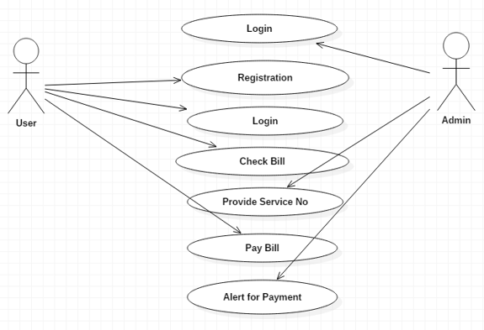

Figure 2

The diagram above shows the use case model of the system and the activities carry by each

actor in the system.

3.8.3 Data Design

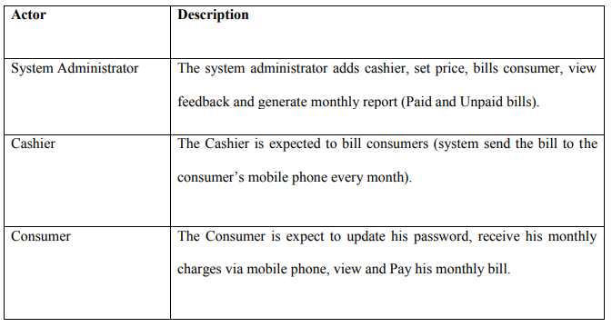

Figure 3

The database is the core of any information system. The nature of data stored in the database as well as the organization of the data has wide effect on the performance of the system. A good database design should hold all the data, which may be required by the users of the system, but at the same time, avoid any harmful or unnecessary redundancy. The database should also be flexible so that any future change in requirements can be incorporated with minimum changes.

The data in this system is organized in the form of 2-Dimension relational tables. Organization of data into tables allows easy categorization, retrieval and storage of data. Different tables have been created for different type of information. The rules of normalization have also been applied while designing the tables.

Since the system requirement some manipulation of data, some of the tables used are almost static in nature and are already available with the standard data for the selection of the parameter values. Other tables are used with bi-directional role of data i.e. for both input and output. During database design six (6) tables were designed among which is:

|  |  |  |  |
| --- | --- | --- | --- |
| Name | Type |  | Status |
|  |  |  |  |
| Uid | Int(11) | | not null |
|  |  |  |  |
| Username | varchar(30) | | not null |
|  |  |  |  |
| Email | varchar(150) | | not null |
|  |  |  |  |
| Password | varchar(200) | | not null |
|  |  |  |  |
| access_level | varchar(1) | | not null |
|  |  |  |  |
|  | *: User table* | |  |

|  |  |  |  |  |  |  |  |  |  |  |  |  |
| --- | --- | --- | --- | --- | --- | --- | --- | --- | --- | --- | --- | --- |
| Name | | | Type | | | | | Status | | | | |
|  | | |  | | | | |  | | | | |
| Id | | | int(11) | | | | | not null | | | | |
|  | | |  | | | | |  | | | | |
| Uid | | | int(11) | | | | | not null | | | | |
|  | | |  | | | | |  | | | | |
| Fname | | | varchar(50) | | | | | not null | | | | |
|  | | |  | | | | |  | | | | |
| Lname | | | varchar(50) | | | | | not null | | | | |
|  | | |  | | | | |  | | | | |
| Dob | | | varchar(100) | | | | | not null | | | | |
|  | | |  | | | | |  | | | | |
|  | | |  | | | *Cashiers_bio table* | |  | | |  | |  | | |
|  | | |  | | |  | |  | | |  | |  | | |
| Name | | |  | | | Type | |  | | | Status | |  | | |
|  | | |  | | |  | |  | | |  | |  | | |
| Id | | |  | | | int(11) | |  | | | not null | |  | | |
|  | | |  | | |  | |  | | |  | |  | | |
| Uid | | |  | | | int(11) | |  | | | not null | |  | | |
|  | | |  | | |  | |  | | |  | |  | | |
| Fname | | |  | | | varchar(30) | |  | | | not null | |  | | |
|  | | |  | | |  | |  | | |  | |  | | |
| Lname | | |  | | | varchar(30) | |  | | | not null | |  | | |
|  | | |  | | |  | |  | | |  | |  | | |
| phone_number | | |  | | | varchar(11) | |  | | | not null | |  | | |
|  | | |  | | |  | |  | | |  | |  | | |
| Dob | | |  | | | varchar(15) | |  | | | not null | |  | | |
|  | | |  | | |  | |  | | |  | |  | | |
| Address | | |  | | | varchar(200) | |  | | | not null | |  | | |
|  | | |  | | |  | |  | | |  | |  | | |
|  | | |  | | | *patients_table* | |  | | |  | |  | | |
|  | | |  | | |  | |  | | |  | |  | | |
| Name | | |  | | | Type | |  | | | Status | |  | | |
|  | | |  | | |  | |  | | |  | |  | | |
| Bid | | |  | | | int(5) unsigned zerofill | |  | | | not null | |  | | |
|  | | |  | | |  | |  | | |  | |  | | |
| Id | | |  | | | int(10) | |  | | | not null | |  | | |
|  | | |  | | |  | |  | | |  | |  | | |
| Reading | | |  | | | varchar(20) | |  | | | not null | |  | | |
|  | | |  | | |  | |  | | |  | |  | | |
| Period | | |  | | | varchar(20) | |  | | | not null | |  | | |
|  | | |  | | |  | |  | | |  | |  | | |
| Status | | |  | | | int(11) | |  | | | not null | |  | | |
|  | | |  | | |  | |  | | |  | |  | | |

|  |  |  |  |
| --- | --- | --- | --- |
| bill_timestamp | int(19) |  | not null |
|  |  |  |  |
| default_msg_stat | int(11) | | not null |
|  |  |  |  |
|  | *Bill_table* | |  |

|  |  |  |  |
| --- | --- | --- | --- |
|  |  |  |  |
| Name | Type | | Status |
|  |  |  |  |
| price_id | int(11) | | not null |
|  |  |  |  |
| price_value | float(6,2) | | not null |
|  |  |  |  |
|  | *Table 4.6: Price_table* | |  |

3.8.4 Activity Diagrams

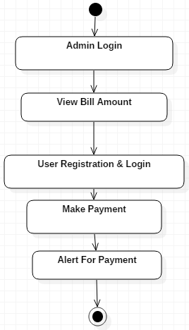

Figure 4

3.8.5 Class Diagram

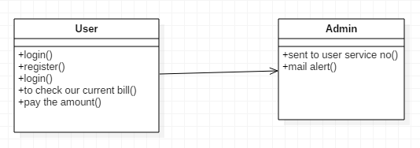

Figure 5

3.8.6 ER Diagram

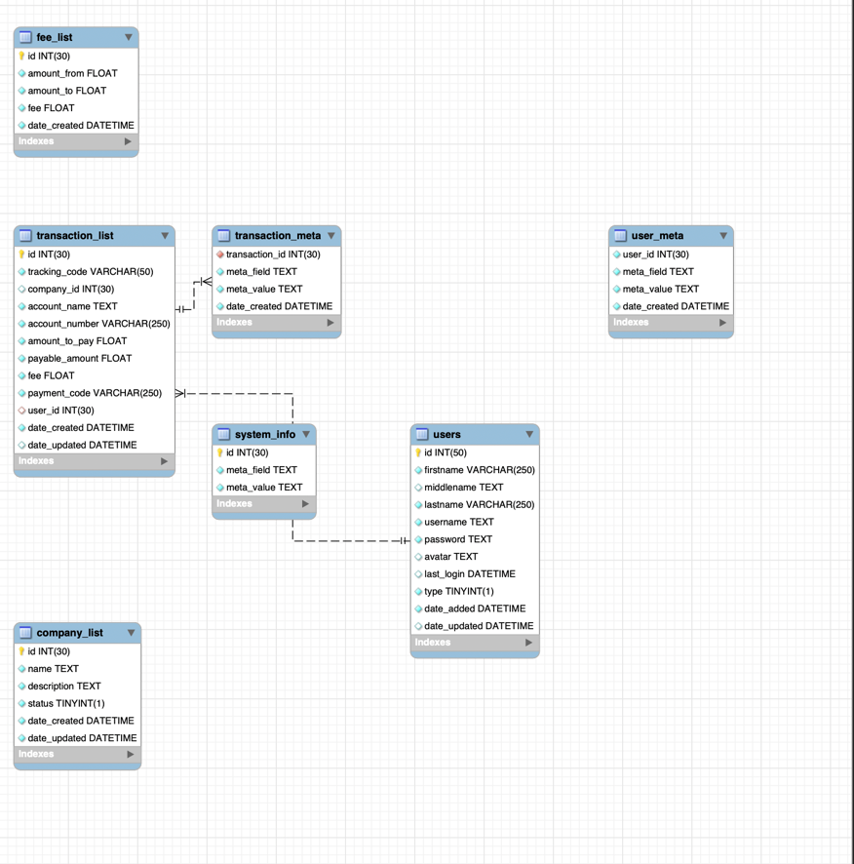

Figure 6

3.8.7 Dataflow Diagram

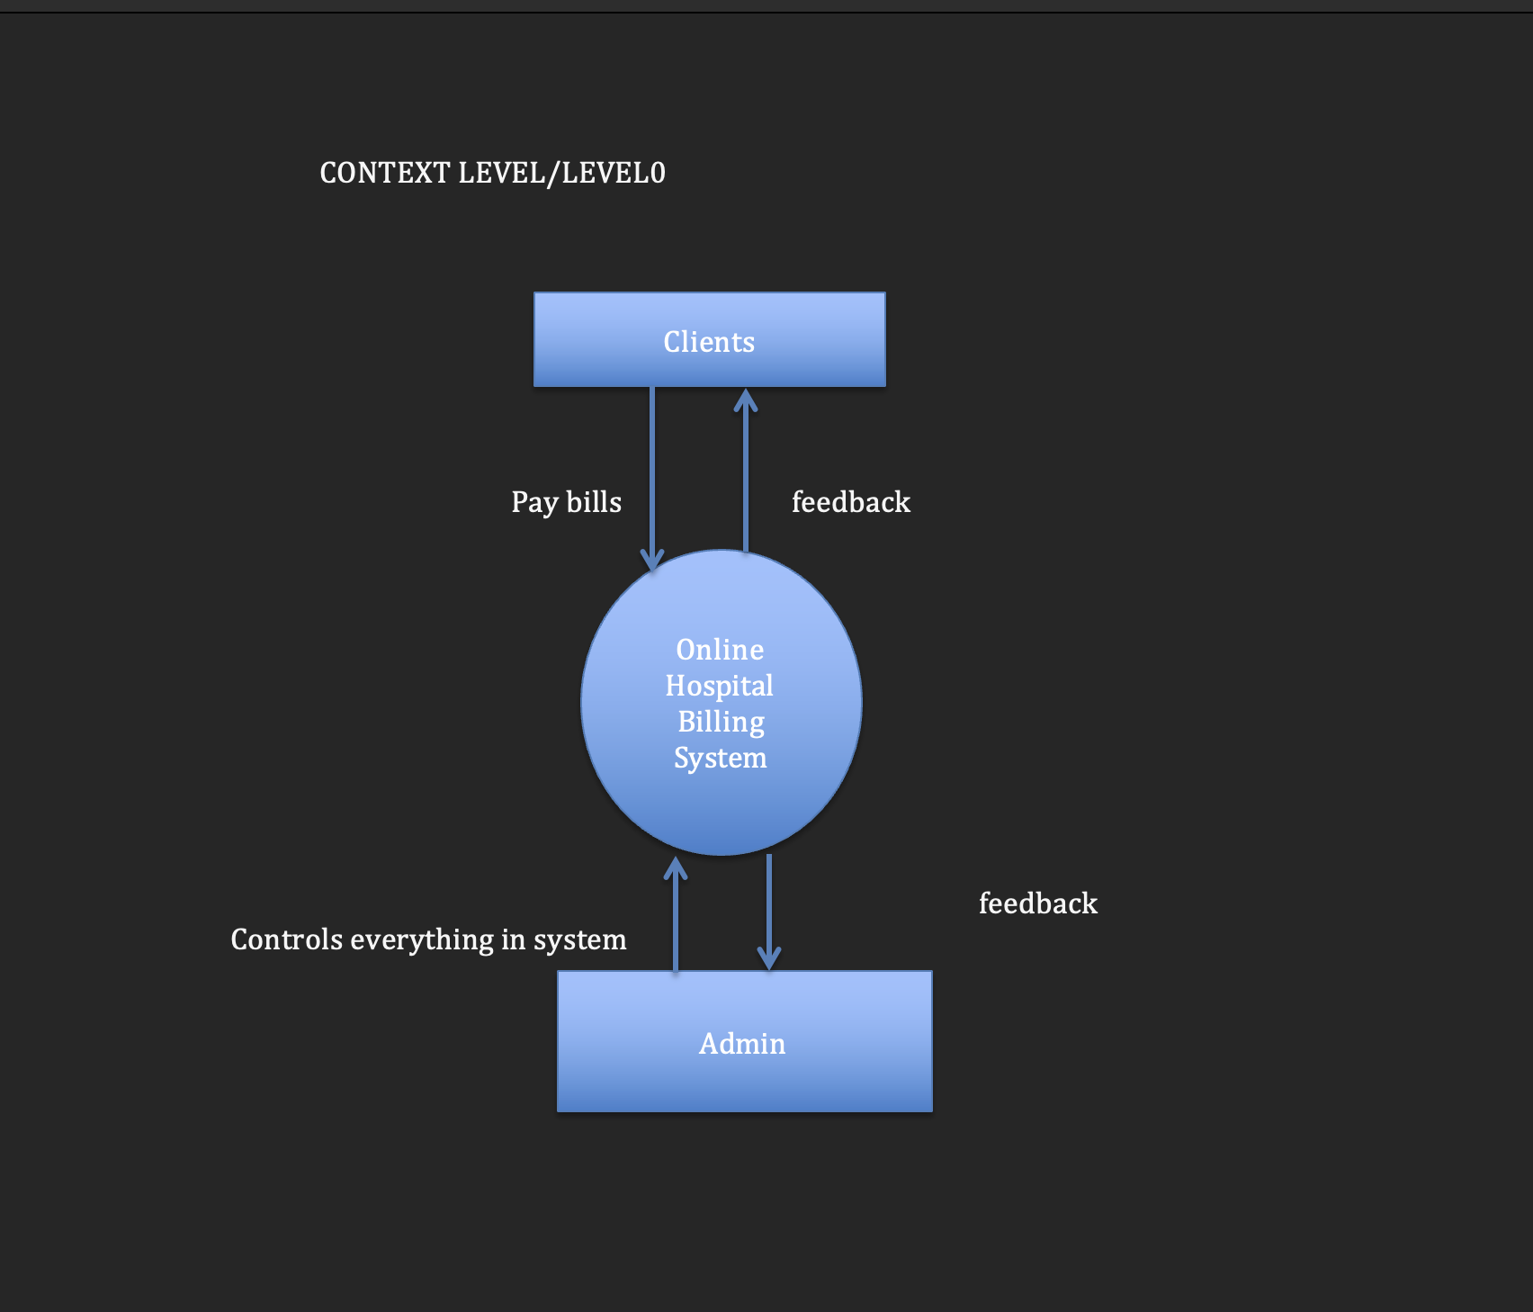

Figure 7

LEVEL1 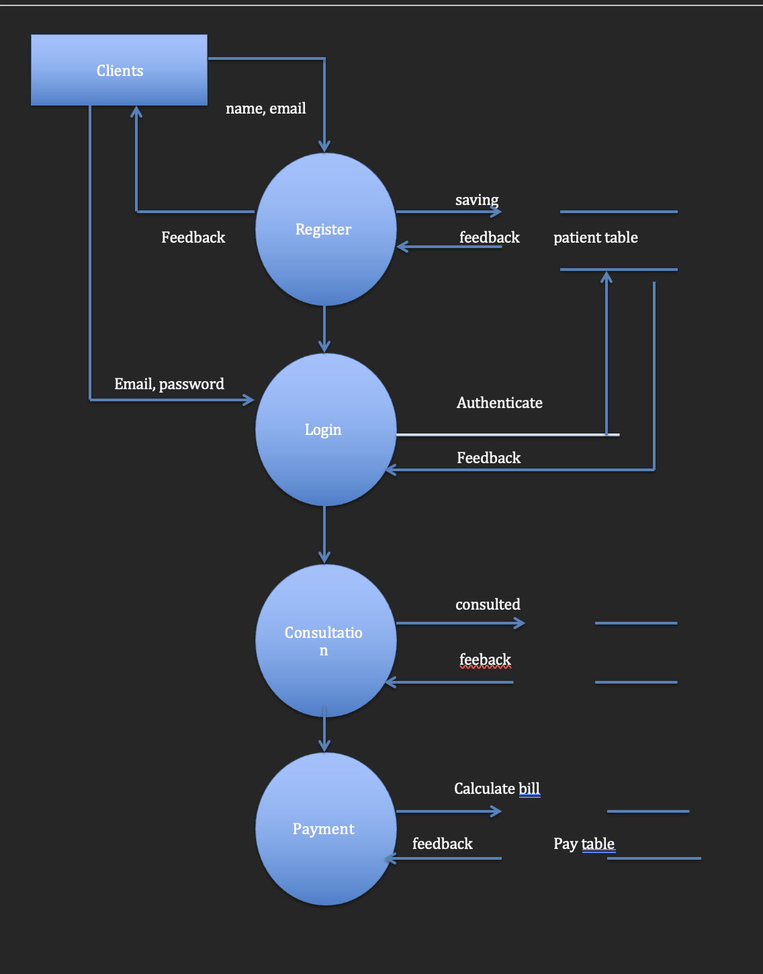

Figure 8

3.9 Summary

Billing using an automated system means that all information management, Billing and payment processes will be done online, which will make it faster instead of the present manual system. All information saved on an online system are stored in a database, therefore it will be kept for as long as it is needed.

Time sharing is also another advantage of an online system for managing and searching of document. In a network environment, more than one person could read the information about a particular consumer or bill at the same time but it varies in current manual system.

The aim of any information system is to improve the efficiency of already existing system irrespective of the system type (i.e. manual or automated). This efficiency can be achieved by proper planning because it is like training a computer to behave like a human being, so the process of designing an SMS based Water Billing System is a complex task that requires its own expertise.

## CHAPTER FOUR

IMPLEMENTATION AND TESTING

## 4.1 Overview

It shows the results and interfaces of the system with aid of images. Moreover, discusses tests performed on the system.

## 4.2 Main Features

Here are some of the main features of the system:

1. Patient Registration:
2. Electronic Billing and Invoicing
3. E-wallet module

# 4.3 Implementation Problems

During the Implementation process of the patient billing system for Nigeria Navy healthcare facilities encounter five main problems:

1. Data Integration Challenges: Integrating with existing electronic health records and financial systems was difficult due to differences in data formats and standards.
2. Resistance to Change: Healthcare staff resisted adopting new technologies and processes, leading to slow adoption and potential pushback.
3. Data Quality and Accuracy: Ensuring accurate patient data, payment information, and billing codes is crucial to avoid errors and claim denials.
4. Training and Skill Gaps: Staff training to effectively use the new system, and inadequate training can result in errors and inefficiencies.
5. Compliance and Regulatory Issues: Meeting complex healthcare billing regulations was challenging and require continuous monitoring and updates.

## 4.4 Overcoming Implementation Problems

To overcome implementation problems when introducing the patient billing system for Nigeria Navy healthcare facilities, these five key strategies were considered:

1. Data Integration: Collaboration with IT experts to ensure smooth integration, identifying discrepancies and establishing clear data transfer protocols.

2. Change Management: Implement change management strategies by involving stakeholders early, communicating benefits, providing training, and actively addressing concerns.

3. Data Quality: Develop validation processes, implement data quality checks, and provide training to ensure accurate patient data and billing codes.

4. Training Programs: Invest in comprehensive training, identifying needs, offering hands-on sessions, ongoing support, and user-friendly documentation.

5. Compliance Framework: Establish a compliance management framework, conduct regular audits, stay updated on regulations, and integrate compliance checks into the system.

## 4.5 Testing

Testing is the process that is carried out to ensure that the system conforms to the specification and meets the requirements of the users, namely staff, administrator and customers. Testing had been conducted not only in the end but also during the development of the prototype system. Functional and interface testing were carried out for the module or for the whole system. Each link had been checked to make sure all the links are working correctly. Interface testing is carried out to identify that the interface works correctly, and faults are not created because of interface errors.

4.5.1 Unit Testing

Unit Testing is to test software in terms of a unit, a module, a function, a specific section of code. This testing occurs while the software is being developed and before completion (David Fletcher, 2000).

For Unit Testing, test cases are designed to verify that an individual unit implements all design decisions made in the unit's design specification. A thorough unit test specification should include positive testing where the unit does what it is supposed to do, and also negative testing where the unit does not do anything that it is not supposed to do. Table 4.1 shows the Unit Testing for the Administrator login module.

4.5.2 Test Suite (for Unit Testing, Integration Testing, and System Testing)

A test suite for implementing a patient billing system for Nigeria Navy healthcare facilities includes test cases and configurations for unit testing, integration testing, and system testing. Each suite outlines objectives, test data, environment details, execution instructions, results recording, and specific metrics to ensure systematic and effective testing.

## 4.6 User Guide

This comprises of all descriptive materials necessary for the user to participate in the running of operational system. They include schedule for the collection and preparation of data, prior to submission of data processing operation.

The user documentation, which is meant for end users to understand system, this research will be presented in two ways.

1. On a Web Server
2. On a local Server

On a web server: This involves:

1. Launch your browser, e.g., Mozilla Firefox, Google Chrome etc.
2. Type the domain name at the address bar of your browser.
3. Press Enter key.
4. Start browsing through the application.

On a local Server: If you want to run this application on a local server what you need to do are.

Get a server installed on your system (e.g. WAMP, XAMP Server Software etc.).

1. Copy your project to ‘www’ folder of the WAMP Server or ‘httdocs’ of the XAMP Server.
2. Launch the WAMP/XAMP Server
3. Click on WAMP icon at the task bar,
4. Select Local host, this will open your browser,
5. On your browser, you will see your project folder,
6. Click on Application name to launch the application.
7. Enter Username and Password to login to the Application as an Admin or Student

## 4.7 Result Presentation

HOME PAGE

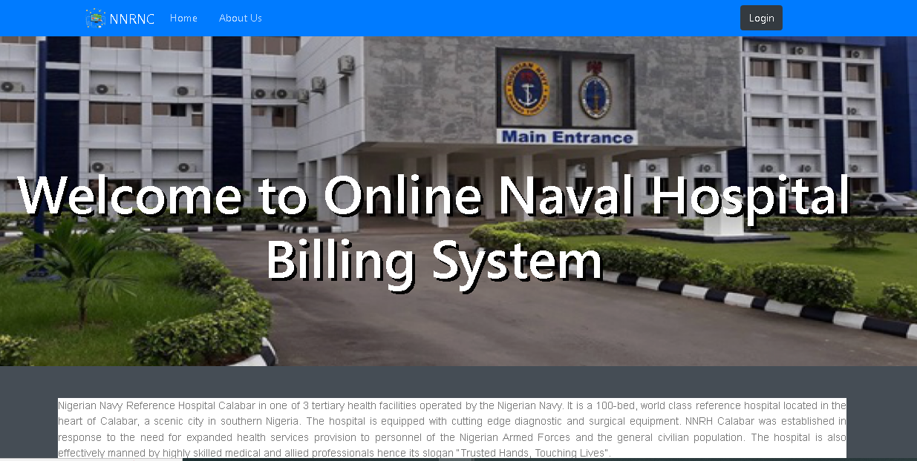

LOGIN PAGE

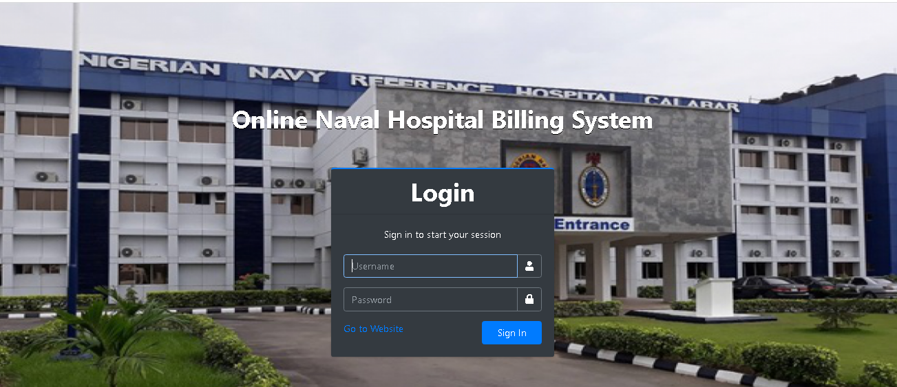

PATIENT REGISTRATION PAGE

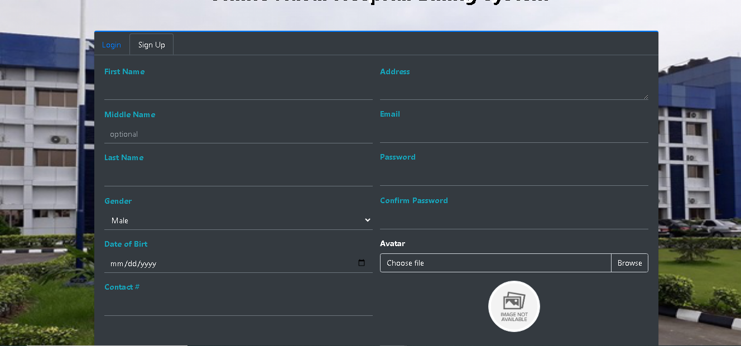

PAYMENT PAGE

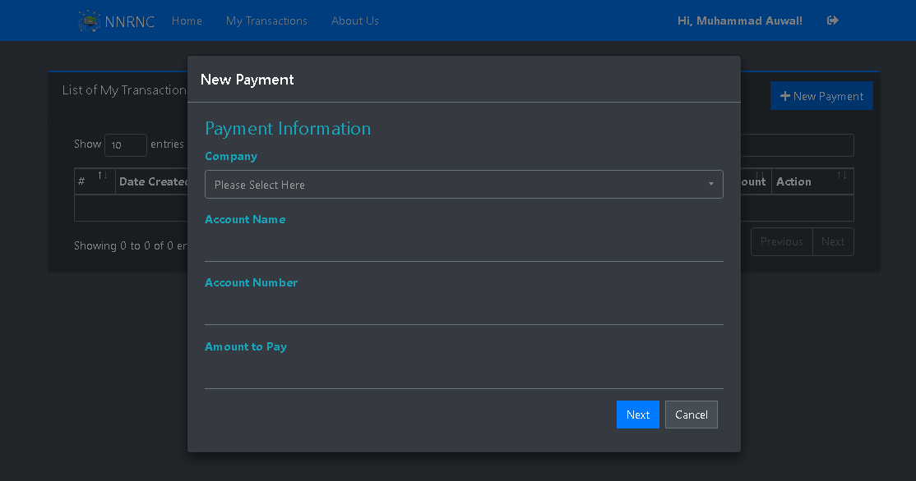

ADMIN DASHBOARD

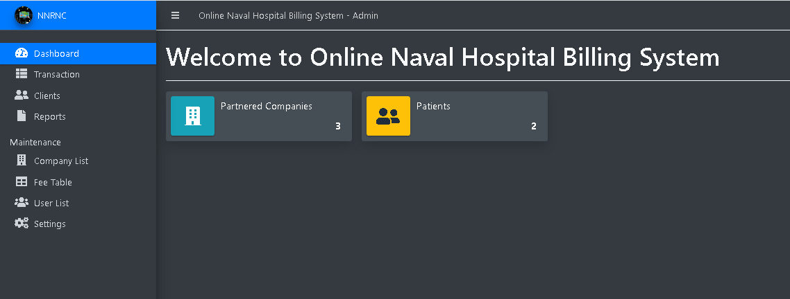

REGISTERED PATIENT

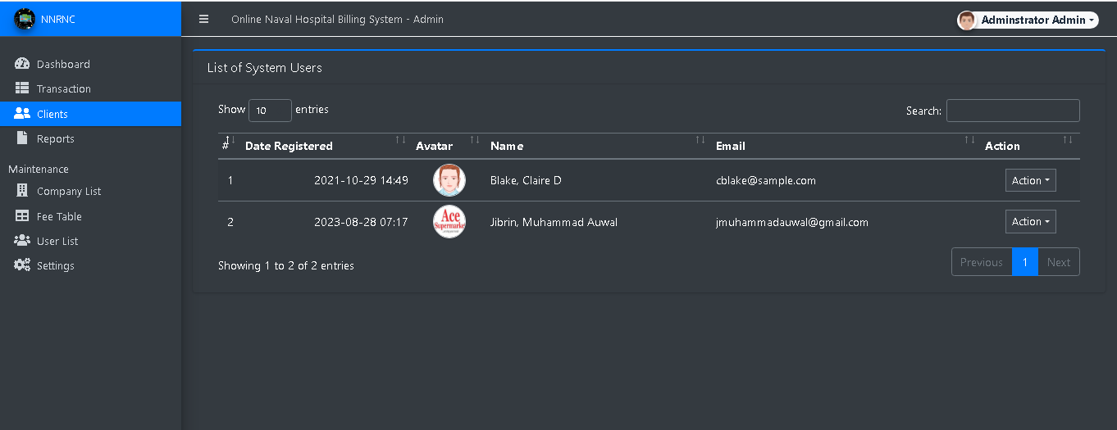

# References

Abbey, D.C. (2012) *Healthcare Payment Systems* [Preprint].

Ajayi, O. O., Akinrujomu, O. S., Daso, O. S., & Paulina, A. O. (2019). A mobile based medical appointment and consultation (MMAC) system. *International Journal of Computer Science and Mobile Computing*, *8*(5), 208-218

Akinode, J. L., & Oloruntoba, S. A. (2017). Design and implementation of a patient appointment and scheduling system. *Department of Computer Science, Federal Polytechnic Ilaro Nigeria*.

Anusi, I.H. and Mutambara, E. (2022) ‘Digital Technology and Health Workers’ performance: A case of hospitals in Nigeria and South Africa’, *International Journal of Social Science and Religion (IJSSR)*, 3(3), pp. 2723–5920. doi:10.53639/ijssr.v3i3.118.

Balaraman, P. and Kosalram, K. (2013) ‘E –Hospital Management & Hospital Information Systems – Changing trends’, *International Journal of Information Engineering and Electronic Business*, 5(1), pp. 50–58. doi:10.5815/ijieeb.2013.01.06.

Barnett, G.O. *et al.* (1979) ‘COSTAR—a computer-based medical information system for ambulatory care’, *Proceedings of the IEEE*, 67(9), pp. 1226–1237. doi:10.1109/proc.1979.11438.

Berenson, R.A. and Rich, E.C. (2010) ‘US approaches to physician payment: The Deconstruction of Primary Care’, *Journal of General Internal Medicine*, 25(6), pp. 613–618. doi:10.1007/s11606-010-1295-z.

Brook, C. (2020). What is a Health Information System?| Digital Guardian.

Christiansen, L. (2021). The six main types of information systems. From Altametrics: <https://altametrics.com/en/information-systems/information-system-types>

Funmilola, A., & Ozichi, E. (2015). Development of an electronic medical record (EMR) system for a typical Nigerian hospital. *Development*, *2*(6).

Garrido, T. *et al.* (2004) ‘Making the business case for hospital information systems’, *Journal of Healthcare Finance*, 31(2), pp. 21–22.

Geek for geeks. (2021). *Components of information systems*. From Geek for Geeks: <https://www.geeksforgeeks.org/components-of-information-system.com>

Haux, R., Schmücker, P. and Winter, A., (1996) Gesamtkonzept der informationsverarbeitung im krankenhaus. *Management und Krankenhaus*, 11(1996), pp.45-50.

Hennington, A. and Janz, B.D. (2007) ‘Information Systems and healthcare XVI: Physician adoption of electronic medical records: Applying the UTAUT model in a healthcare context’, *Communications of the Association for Information Systems*, 19. doi:10.17705/1cais.01905.

Homayounfar, Payam. (2012). Process mining challenges in hospital information systems. 2012 *Federated Conference on Computer Science and Information Systems, FedCSIS 2012*. 1135-1140.

Kabir, M. A., Saidin, S. Z., & Ahmi, A. (2017). The influence of perceived usefulness and perceived ease of use on the continuous intention to use electronic collection system in Nigerian hospitals: a conceptual approach. *Asian Journal of Multidisciplinary Studies*, *5*(6), 225-229.

Kareem, A., Yahaya, A. and Abimbola, S. (2014) ‘Standards and Resource Utilization Monitoring System: A Concept to Hospital Management in Nigeria’, *Lautech Journal of Engineering and Technology* [Preprint].

Malin, B., (2010) Guidance on De-identification of Protected Health Information. Office for Civil Rights., *US Department of Health & Human Services*.

Menachemi, N. and Collum. (2011) ‘Benefits and drawbacks of Electronic Health Record Systems’, *Risk Management and Healthcare Policy* [Preprint]. doi:10.2147/rmhp.s12985.

Muinga, N. *et al.* (2020) ‘Digital Health Systems in Kenyan Public Hospitals: A mixed-methods survey’, *BMC Medical Informatics and Decision Making*, 20(1). doi:10.1186/s12911-019-1005-7.

Rahman, M.A. *et al.* (2017) ‘Assessing service quality of online bill payment system using extended SERVQUAL model (SERVQUAL-butterfly model): A case study of dhaka electric supply company limited (DESCO), Bangladesh’, *Cogent Business & Management*, 4(1). doi:10.1080/23311975.2017.1301195.

Sikiru, I. A., & Oyekunle, R. A. (2021). Web-based hospital management system. *Adeleke University Journal of Engineering and Technology*, *4*(2), 28-40.

Vawdrey, D. K., Walsh, C., & Stetson, P. D. (2014). An integrated billing application to streamline clinician workflow. *AMIA ... Annual Symposium proceedings. AMIA Symposium*, *2014*, 1141–1149.

Vegoda, P.R. (1987) ‘Introduction to hospital information systems’, *International Journal of Clinical Monitoring and Computing*, 4(2), pp. 105–109. doi:10.1007/bf02915853.

Winter, A., Wendt, T. and Brigl, B. (2003) ‘Modeling Hospital Information Systems (part 1): The revised three-layer graph-based Meta Model 3LGM2’, *Methods of Information in Medicine*, 42(05), pp. 544–551. doi:10.1055/s-0038-1634381.

Zuvekas, S.H. and Cohen, J.W. (2016) ‘Fee-for-service, while much maligned, remains the dominant payment method for physician visits’, *Health Affairs*, 35(3), pp. 411–414. doi:10.1377/hlthaff.2015.1291.